Welcome to Non-Fiction
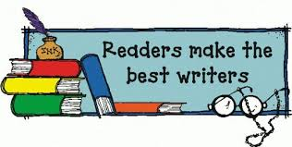
Reading and Writing!
Today is Monday, March 28, 2016
This is what today will like:
I hope you had a wonderful break!!

- Monday, Tuesday and Wednesday this week we will be working on:

- Typing up our final draft (rough drafts should have been turned in the Friday before break)

- Practicing/ typing up our speeches.

- Printing any pictures or papers that you need to complete your project!

Welcome to Non-Fiction
Reading and Writing!
Today is Tuesday, March 28, 2016
This is what today will like:

- This week we will be working on:

- Typing up our final draft (rough drafts should have been turned in the Friday before break)

- Practicing/ typing up our speeches.

- Printing any pictures or papers that you need to complete your project!

Welcome to Non-Fiction
Reading and Writing!
Today is Wednesday, March 30, 2016
This is what today will like:

- This week we will be working on:

- Typing up our final draft (rough drafts should have been turned in the Friday before break)

- Practicing/ typing up our speeches.

- Printing any pictures or papers that you need to complete your project!

Today is Thursday, March 31, 2016
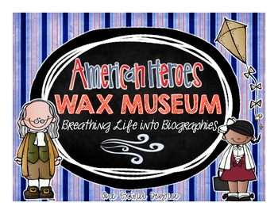
Welcome to the Nate Mack
Nevada Wax Museum

Wax museum rules:
- Please do not touch the statues or boards.
- Keep your hands to yourself.
- Please only push the button one time per person.
- Please be a polite listener while the “wax statue” gives their speech. (no talking, stand still, eyes on the statue)
- If you like the speech or board positive feedback is always welcome!

Today is Friday, April 1, 2016
Welcome to the Nate Mack
Nevada Wax Museum

Wax museum rules:
- Please do not touch the statues or boards.
- Keep your hands to yourself.
- Please only push the button one time per person.
- Please be a polite listener while the “wax statue” gives their speech. (no talking, stand still, eyes on the statue)
- If you like the speech or board positive feedback is always welcome!

