Finally! The moment you have been waiting for: The 4th Grade Live Wax Museum!!! Each of you will be given a person (character) who has made positive contributions to the history of Nevada. In order to do an awesome, exciting wax museum project, here are your expectations:

❖
❖
❖
Create a tri-fold poster boarrd report which will also serve as a backdrop.
Prepare an informational speech that you will present to the class and at the wax museum. Dress up as your character for the wax museum.
This packet includes:
- Project checklist/rubric
- Tri-fold poster report instruction sheet
- Notes sheet for the poster
- Speech presentation instructions
- Directions for more research
- Speaking tips
- Parent signature sheet
- Bibliography help paper

The tri-fold poster report and oral presentation are due promptly on Tuesday, March 29th . You are expected to have your oral presentation memorized. Make sure you practice it at least three times in front of an audience (mom, dad, sister, brother, stuffed animals, your pet….☺).

The Fourth Grade Wax Museum will take place on Thursday, March 31st and Friday April 1st in room 15 (Don’t worry parents, we will send a note home about the times :) Students will dress up as your character and pose by your poster as parents and other classes come in to see your character. You will have a button that “activates” the information about your character. Then you will step out of your pose to present your information to them. When you are done telling them all about your character, you will return to your frozen position.

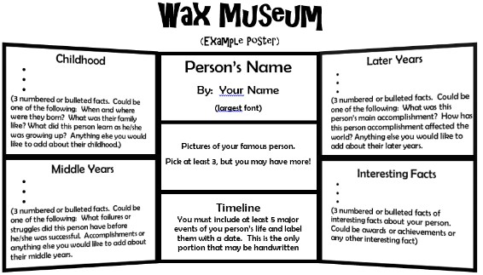
Parents, thank you for your encouragement, support, and for
helping to make your child’s project successful!!

Sincerely,
Ms. Delzeit

Project Expectations/Rubric

Use the following checklist to make sure you fulfill all of the requirements.

Check these items off as you finish them:

I was assigned a person for my Wax Museum project.

I read at least one complete book about my person.

I took notes, while I was reading, about my person.

I have a tri-fold poster to use for my project.

I put a title on my poster.

______ I have 3 facts about my person’s childhood.

_____ I have 3 facts about my person’s middle years.

______ I have 3 facts about my person’s later years.

I have 3 interesting facts I learned.

Each section of my poster has a title.

My poster is illustrated with pictures and captions.

My poster has a timeline.

Explanation of Nevada contribution.

I practiced my speech presentation in front of someone at least 3 times.

I have a costume prepared for the live Wax Museum presentation.

Notes for Tri-fold Poster Board Report

(This will be done in class)

Name of your character

Early Childhood
(Information like when and where were they born, what their family was like, what the person learned as they were growing up, or any other important early childhood facts go here.)
1.

2.

3.

Middle Years
(Information like failures or struggles this person had before he/she was successful, accomplishments that affected Nevada).

1.

2.

3.

Later Years
(Information like their main accomplishment, accomplishments that affected Nevada).

1.

2.

3.

Notes for Tri-fold Poster Board Report (Page 2)

(This will be done in class)
Interesting Facts
(Information like awards, achievements or any other facts that are not listed in any other area).

1.

2.

3.

Timeline Notes
(list important events and dates for your character)

Date Important Events including Nevada

Speech Notes and Instructions

(This will be done in class and at home)

This is an example presentation. You need to include facts from your character. Make your presentation interesting for your audience.

Hello, my name is George Washington. Yes, THE George Washington. I was born on February 22nd, in Westmoreland County, Virginia. I am famous and important because I was the first president of the United States of America. Something interesting about my life is I was the only president to be elected unanimously. I would like to be remembered as a hard worker and someone who is principled (that means do what is right). Did you know…I never had wooden teeth? Thank you very much and have a nice day :D

Write your information speech on the lines below. Your speech should be 30-60 seconds long. (You may not use note cards when you present, you must practice and be prepared).

Hello, my name is I was born on date),
in (location). I am famous (or important) because

Something interesting about my life is

I would like to be remembered as

Did you know…… _________________________________________________________
Thank you and have a nice day.

Public Speaking Tips

Speaking Tip #1:
Practice your speech ahead of time in front of a mirror!
Speaking Tip #2:
Make sure your listeners can see your face.
Speaking Tip #3:

Look up from your page and your listeners as often as you can.

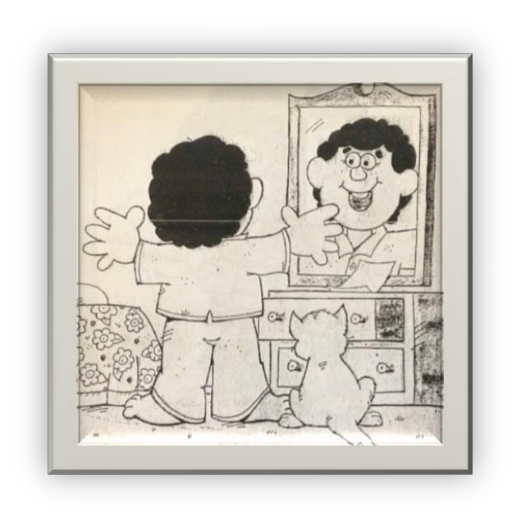
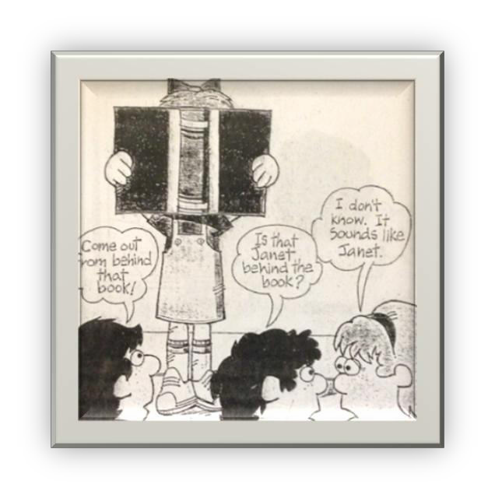
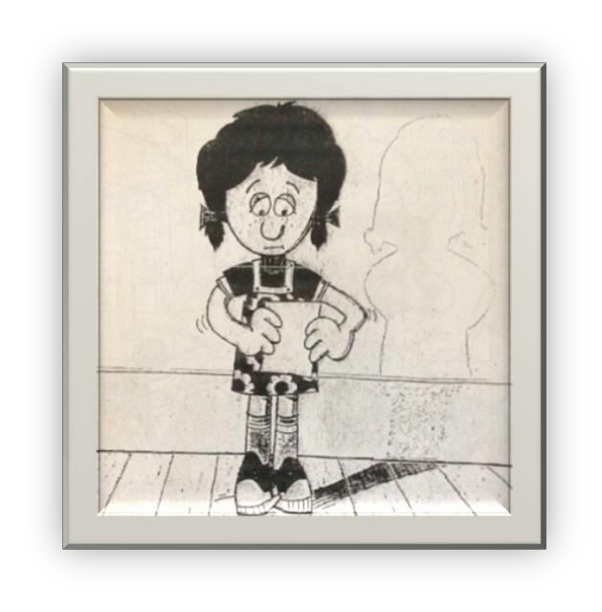
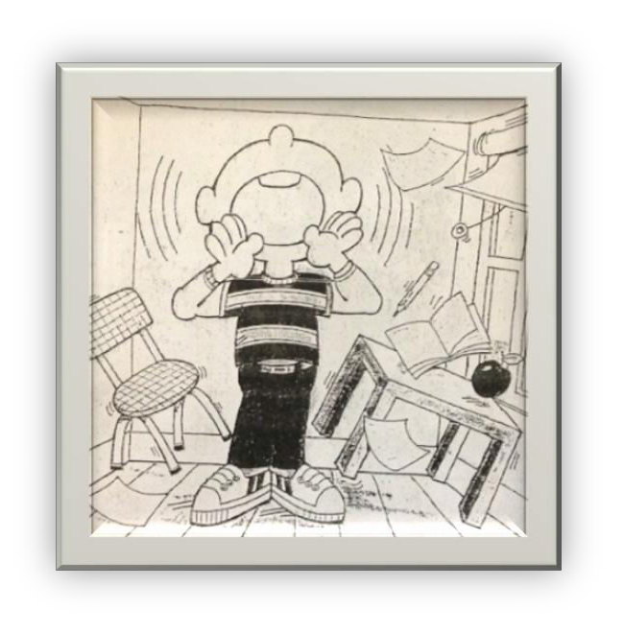
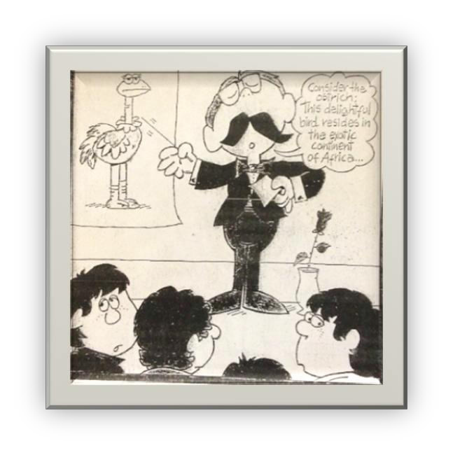
Speaking Tip #4:
Speak loudly & clearly so that everyone can hear you.
Speaking Tip #5:
Read the words the way you talk so that you sound natural.
Speaking Tip #6:
If you lose your place while speaking, don’t panic!!

Project Outline and Due Dates

Project Component Due Date

Parent signature ½ page due: March 14, 2016

Biography Organizer/ Notes: March 15, 2016

Written Report March 18, 2016

Wax Museum Speech March 28, 2016

Poster Board: March 29, 2016

Please detach, sign and return to Ms. Delzeit
Parent Signature Page

I realize that (child’s name)_____________________________________ has to:

- read a biography
- create a tri-fold poster board report
- prepare a 30-60 second informational speech on the life of that character
- dress up as their character and participate in the live Wax Museum
- Turn in above project requirements on the due date noted

X
Parent’s Signature Date

This is what you will be graded on:

I. Display Board
A. Character’s Name & Picture/Portrait
• Character’s name - 2”-3” in height, centered at top of poster
• Portrait of individual centered below the title
• Tri-fold Poster Board

B. Vital Statistics:
• Date and location of birth and death - mandatory
• Family(spouse, children, etc.)
• Early childhood, Middle Years & Later years
• How they contributed to Nevada
• Hobbies/Passions
• Interesting Facts
- Timeline

C. Major Accomplishments
• List and describe this person’s major accomplishments and how they impacted Nevada.
• What was this person’s significant contribution to society and Nevada?

D. Board Presentation
• Make display board pleasing to the reader- add an attractive border design and/or other pictures
• Put your name in the lower right hand corner
• Be creative and neat…i.e. measure, write in straight lines, appropriate use of color, eye-catching
• Use proper spelling, grammar & punctuation

II. Presentation
A. Costume, Props, Character Portrayal
• What do I plan to wear? What props do I need? What poses would be appropriate for my character?

B. Oral Presentation
• Make sure you have your oral presentation memorized
• Make sure your oral presentation is between 30-60 seconds long
• Make sure you include all of the information required
• Speak loudly and clearly (practice this part!)

Name: ___________________________
Bibliography of Sources Used
Book:
Book Title: ____________________________________________________
Author _______________________________________________________
Name of Publisher ______________________________________________
Date Published _________________________________________________

Encyclopedia Book:
Print Encyclopedia Title __________________________________________
Volume _______________________________________________________
Name of Publisher _______________________________________________
Date Published __________________________________________________
Article Title ____________________________________________________

On-Line Encyclopedia:
On-line Encyclopedia Title _______________________________________
Article Title _______________________________________________
Date you used this site __________________________________________

Internet Web Site:
Internet Web Site Title __________________________________________
Article Title _______________________________________________
Date you used this site __________________________________________

Internet Web Site:
Internet Web Site Title __________________________________________
Article Title _______________________________________________
Date you used this site __________________________________________

